Strings Assignment

1. Given a string of odd length, return the string length 3 from its middle, so "Candy" yields "and". The string length will be at least 3.
2. Given 2 strings, a and b, return a new string made of the first char of a and the last char of b, so "yo" and "java" yields "ya". If either string is length 0, use '@' for its missing char.

Inheritance

1. Develop an application for Dessert shop. The application should allow owner to add items like Candy, Cookie or IceCream in the shop storage. Also customers should be able to place an order.

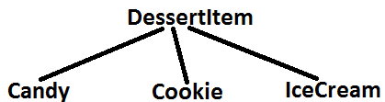

DessertItem is an abstract class having an abstract method getCost(). Every dessert item has tax associated. Candy item is sold in dollar currency, Cookie in Euro currency & IceCream in Rupees currency.

The sub classes are supposed to override these methods. When we run the application It should ask for the role, If role is customer, then we should be able to place an order. The currency conversion rates are:

1 dollar = 74.34 rupees.

1 euro = 84 rupees.